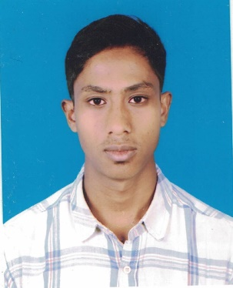Md. Serajul islam

## 306, South Kafrul, Kafrul, Dhaka Cantonment, Dhaka-1206 01622868646, 01982108206 mserajul05@gmail.com

# OBJECTIVE

To succeed in an environment of growth and excellence and earn a job which provides me job satisfaction and self development and help me achieve personal as well as organizational goals.

# Work Experience

01.03. 2016 – **Central Motors Co.**

31.12.2017 **Post:** Operation &Maintenance.

# Education

**Diploma in Institution :** Dhaka Polytechnic Institute

**Engineering Board :** Bangladesh Technical Education Board, Dhaka

**(4 years) Department :** Mechanical  
 **Session :** 2011-2012  
 **Result :** 2.92 (out of 4)

**S.S.C.** **Institution :** Bir Uttam Shaheed Samad High School  
 **Group :** Science  
 **Board :** Dinajpur   
 **Passing Year :** 2011  
 **Result :** 4.81 (out of 5.00)

Languages

Bengali Native speaker

English Intermediate

# Professional training

**1**. Successfully completed the 8th semester with 1st three months experience in

“**Bangladesh Water Development Board "**Tejgaon I/A, Dhaka-1208.

**2.** Successfully completed 3 months industrial training on **Dhaka Polytechnic Institute,** Tejgaon I/A, Dhaka-1208.

**3.** Auto cad (2D& 3D), Solid works, **Institute: CADD CORE**, Office: 57/C, Purbo Raja Bazar, Farmgate, Dhaka- 1215, Bangladesh.

# computer

Operating Systems Windows Operating System

Software Ms-Word, Ms-Excel, Auto Cad 2D 3D, Internet Browsing , Ms Power Point.

# PERSONAL INFORMATION

Name Md. Serajul Islam

Father’s Name Late. Osman Gony

Mother’s Name Most. Sultana Begum

Permanent Address Vill: Vogibalapara, P.O:Upashar , P.S: Kotowali, Dist: Rangpur

Date of Birth 22/09/1996

Gender Male

Marital Status Unmarried

Religion Islam

Nationality Bangladeshi (By Birth)

Height 5ft. 6inch

# REFERENCE

Syed Masudul Hoque

Deputy Director

Department of Foreign Exchange Inspection

Bangladesh Bank

Mobile no. 01618008108

E-mail. masudul.hoque@bb.org.bd

MD. SERAJUL ISLAM